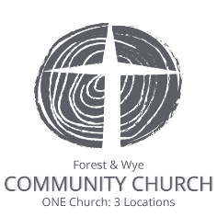
Forest of Dean Community Church
Station Street
Cinderford
GL14 2JT

Gift Aid

Church bank details: HSBC Sort code:40-17-24, account no: 91459805

Boost your donation by 25p of Gift Aid for every £1 you donate

Gift Aid is reclaimed by the church from the tax you pay for the current tax year. Your address is needed to identify you as a current UK taxpayer.
In order to Gift Aid your donation you must tick the box below:

I want to Gift Aid any donations I make in the future or have made in the past 4 years to Forest of Dean Community Church.

I am a UK taxpayer and understand that if I pay less Income Tax and/or Capital Gains Tax than the amount of Gift Aid claimed on all my donations in that tax year it is my responsibility to pay any difference.

My Details

Title ______________First name or initial(s) _________________________________________

Surname _____________________________________________________________________

Full Home address _____________________________________________________________

_____________________________________________________________________________

_____________________________________________________________________________

Postcode __________________________

Signed _________________________________ Date ___________________

Please notify the charity if you:
- want to cancel this declaration
- change your name or home address
- no longer pay sufficient tax on your income and/or capital gains

If you pay Income Tax at the higher or additional rate and want to receive the additional tax relief due to you, you must include all your Gift Aid donations on your Self-Assessment tax return or ask HM Revenue and Customs to adjust your tax code.

Return completed form to Church treasurer, Christine Wakerley via email or post.
Email: treasurer@fcchurch.co.uk
Postal address: Forest & Wye Community Church, Station St, Cinderford, Glos. GL14 2JT

